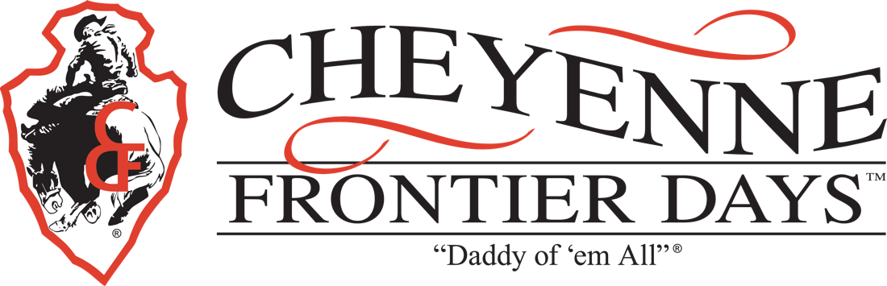

January 21, 2018

We cordially invite your 2018 Fair & Rodeo Queen and her Attendants to participate in the 2018 Cheyenne Frontier Days Parades.

Our authentic western parades take place July 21, 24, 26 & 28, 2018. Visiting royalty will ride in the VIP section of our parades. You may choose to either bring your own horses to ride or we will provide a carriage, wagon or car of our choice for you.

Parades begin promptly at 9:00 a.m. Participants should check in with our Visiting Queen Assistant, Cristin Sevchuk, or Coordinator Becky Hess no later than 8:30 a.m. south of the State Capitol Building at 24th Street and Capitol Avenue.

Please review the enclosed information sheet carefully. We appreciate your compliance with these guidelines. If you have any questions, contact Cristin Sevchuk at (307) 221-5857, cristincfd@gmail.com or Becky Hess at bchess6@hotmail.com.

Visiting Queen entries are due by July 10, 2018. Entry consists of completed entry form and signed waiver. Be sure to keep a copy of this information for future reference. Absolutely no entries will be accepted after July 11, 2018.

It would be an honor to have you join us for the 122nd Cheyenne Frontier Days. We look forward to hearing from you.

Sincerely,

Terry Ruiz
Parades Chairman
Cheyenne Frontier Days, Inc.

TR/dt
Box Office
PO Box 2477
Cheyenne, WY 82003

307.778.7222
800.227.6336
307.778.7229 - Fax

Headquarters
PO Box 2477
Cheyenne, WY 82003
307.778.7201
307.778.7213 - Fax
Last Full Week in July

www.cfdrodeo.com • info@cfdrodeo.com

Cheyenne Frontier Days™
2018 Visiting Royalty Entry Form

Name of Organization: ______________________________________________________________
Person In Charge: ______________________________________________________________
Address of Organization: ______________________________________________________________
______________________________________________________________
Phone Number: (______) ___________________________________
Email: ____________________________________@________________________

1. Queen's Name: ____________________________________________ Age: ________
Attendant Name: ____________________________________________ Age: ________
Attendant Name: ____________________________________________ Age: ________
**ALL names need to be provided (write on additional paper if needed)

2. Entering the Following PARADES:
PARADES Start Promptly At 9:00 a.m.
Saturday, July 21 ________ Thursday, July 26 ________
Tuesday, July 24 ________ Saturday, July 28 ________

Please Be In Front Of the Capitol Building on 24th Street at 8:30 a.m.!!

3. Rodeo Tickets will be given to each participant at time of check in.
(See #5 on Visiting Royalty Information and Parade Route Map Sheet)

4. Participants twelve and under must be accompanied by an adult.

5. Horseback participants must be 13 years or older. If you are unable to provide your own horses for the Parade, carriages, wagons or cars will be available to ride in.

Please indicate if your Queen and her Attendant will be bringing their own horses for the Parade?
Yes ________ No ________

6. I have read the Parade Information Sheet and agree to the terms herein._________________________
Signature of participants or coordinator

PLEASE RETURN THIS ENTRY FORM AND WAIVER VIA MAIL OR EMAIL BY JULY 10, 2018 TO:

Cristin Sevchuk
1518 Copperville Rd
Cheyenne WY 82001
cristincfd@gmail.com

NOTE WAIVER ON REVERSE
WAIVER

Return by July 10, 2018

The undersigned, in exchange for the opportunity to participate in the 2018 Cheyenne Frontier Days™ parades hereby releases and forever discharges Cheyenne Frontier Days™, Inc. as well as their respective sponsors and representatives from any and all claims, demands, and causes of action whatsoever for personal injury or property damage which may arise out of or in connection with participation of the undersigned in the 2018 Cheyenne Frontier Days™ parades. In addition, the group agrees to fulfill the responsibilities as agreed upon with organizers.

Participant(s) agrees to save and hold harmless Cheyenne Frontier Days™, Inc. its officers, employees, and agents, including the City of Cheyenne, Laramie County, against all liability from damage to property or injury or death of any person or persons arising out of it, in any way connected with, or resulting from your participation in the Cheyenne Frontier Days™ parades.

Organization: _________________________________________________________

Contact: _________________________________________________________

__________________________________________________________
(Address)

__________________________________________________________
(City) (State) (Zip)

Phone: __________________________________________________________
(Day) (Evening)

Email: __________________________________________________________

Signature of Group Representative: _________________________________________

** Under Wyoming Law, an equine professional is not liable for an injury to or death of a participant in equine activities resulting from the inherent risks of equine activities. Pursuant to W.S. 1-1-126, please see liability waiver on reverse of entry form.

Mail all information to:
Cristin Sevchuk
1518 Copperville Rd
Cheyenne WY 82001
cristincfd@gmail.com

Cheyenne Frontier Days™ Visiting Royalty Information & Parade Route Map

1. After receipt of your entry form and signed waiver, you will be notified by email or phone of your acceptance or denial of entry into the parade as well as your Agreement to CFD Parades. If for some reason you must cancel, please let us know. The deadline for entries is July 10, 2018 No entries will be accepted after this date. Confirmations of entries will be sent to email provided or via phone.

2. Due to the western theme of Frontier Days, it is a requirement that ALL queens be dressed in western attire and will be enforced. Western jeans, split riding skirts, western skirts are all acceptable. Tank tops, sleeveless blouses and short skirts are not appropriate western attire.

3. If you are unable to provide your own horse(s), carriages, wagons or cars will be available for the parade. We have limited vehicles, and cannot guarantee placement. You and your attendants will ride with other individuals. Because we have so many visiting queens we ask for your cooperation riding in the assigned wagon/car. No outside cars/trucks/floats/trailers. Horses are acceptable.

4. There will be no horse trailers allowed on the park during the rodeos. You are welcome to leave them at the parking lot located downtown at 2100 O'Neil, or park them at the Sheriff's Posse facility located on north Yellowstone about 3 miles north of the park (see #7 below).

5. Those who ride in the parade are invited to be the guest of Miss Frontier, Emily Breeden for the rodeo that day. This invitation is limited to the queen and her attendants. Tickets will be available for pickup at time of check in for each participant. Parents to purchase their own tickets at ticket office 307-778-7200

6. Park & Ride Passes will be available at check in on parade days only. However, only one permit per family is available. Due to the growth of our rodeo, parking passes will be for our Park & Ride Lot. See reverse for parade route.

7. Due to space limitations we are no longer able to offer stalls on the grounds. However, trailer parking is available at the Cheyenne Saddle Tramps. For information www.cheyennesaddletramps.org or email info@cheyennesaddletramps.org

8. To make our job a little easier, we would appreciate it if you could give us the name of the contact person for your organization, or, if you could have your successor contact us, we would be able to send this information directly to this person each year.

9. Under Wyoming Law, an equine professional is not liable for an injury to or death of a participant in equine activities resulting from the inherent risks of equine activities. Pursuant to W.S. 1-1-126, please see liability waiver on reverse of entry form.

10. If you have any questions regarding parades, please contact:

Cristin Sevchuk
1518 Copperville Rd
Cheyenne, WY 82001
(307) 221-5857
cristincfd@gmail.com

11. For the details regarding The Queen’s Brunch, Friday July 20, 2018 contact Miss Frontier, Emily Breeden, miss.frontier@cfdrodeo.com

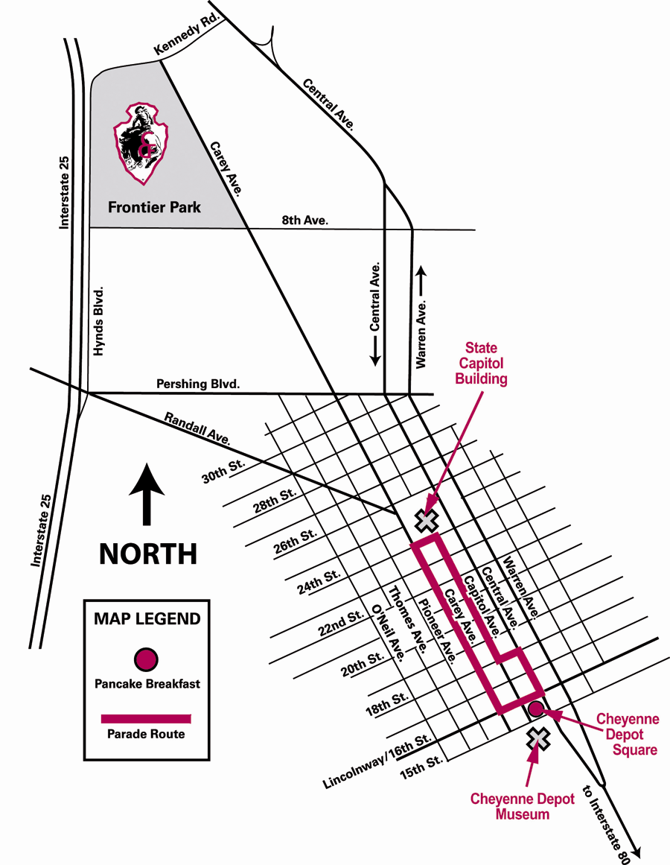

CFD
Park & Ride

